AWS SCREENSHOTS(4)

1.AWS LOGIN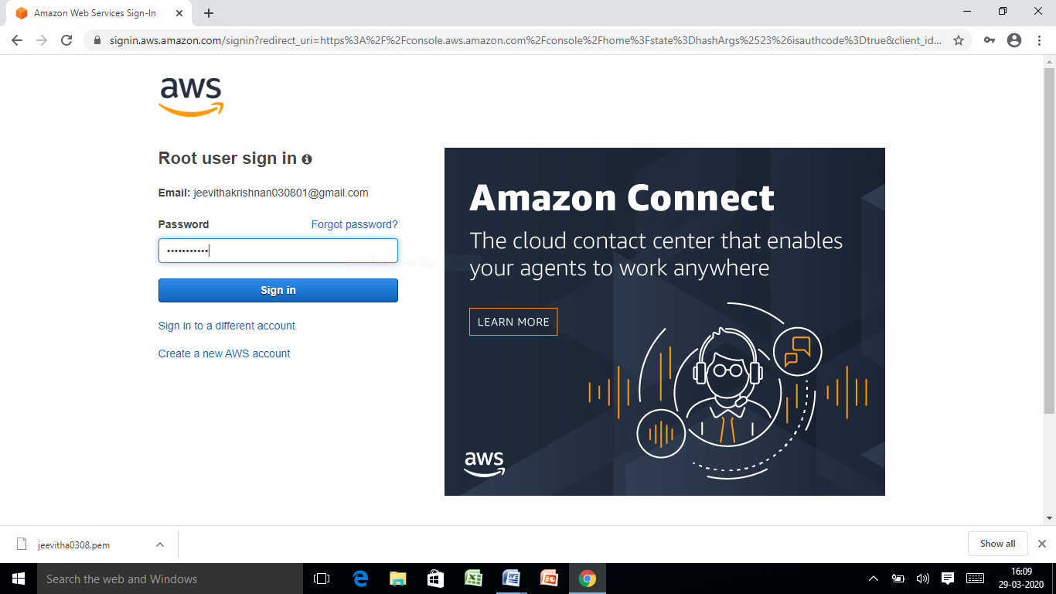

2.EC2 DASHBOARD

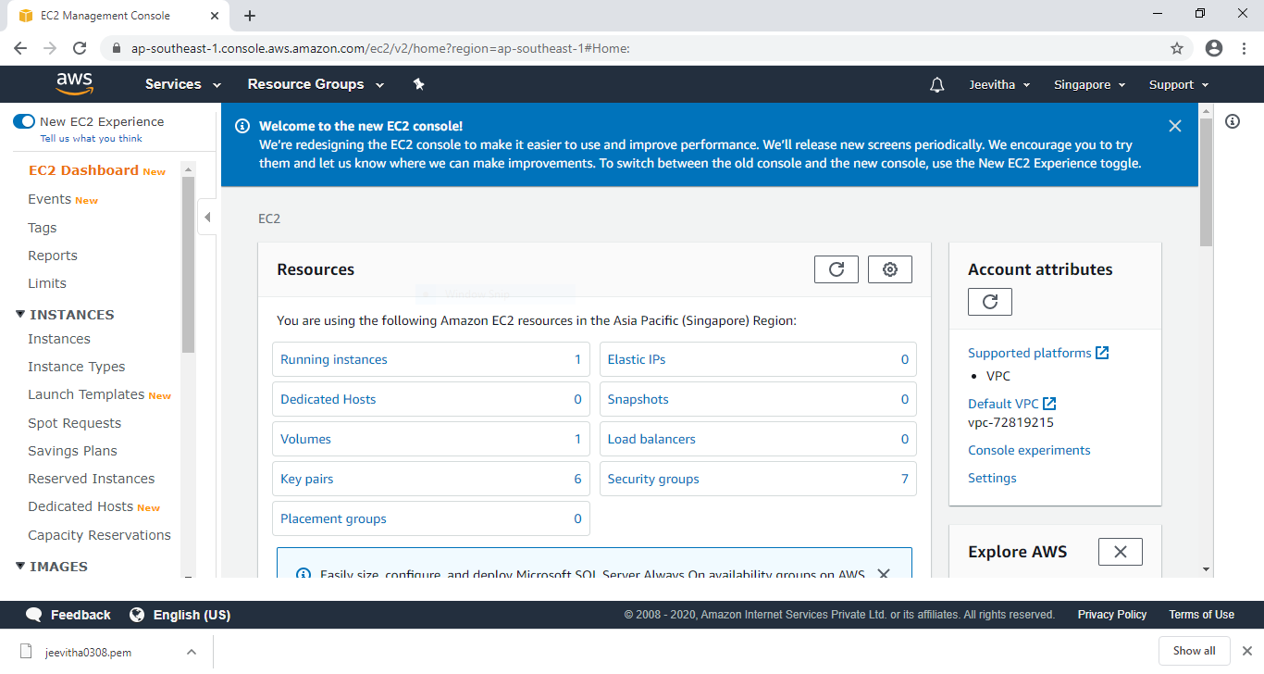

3.S3 DASHBOARD

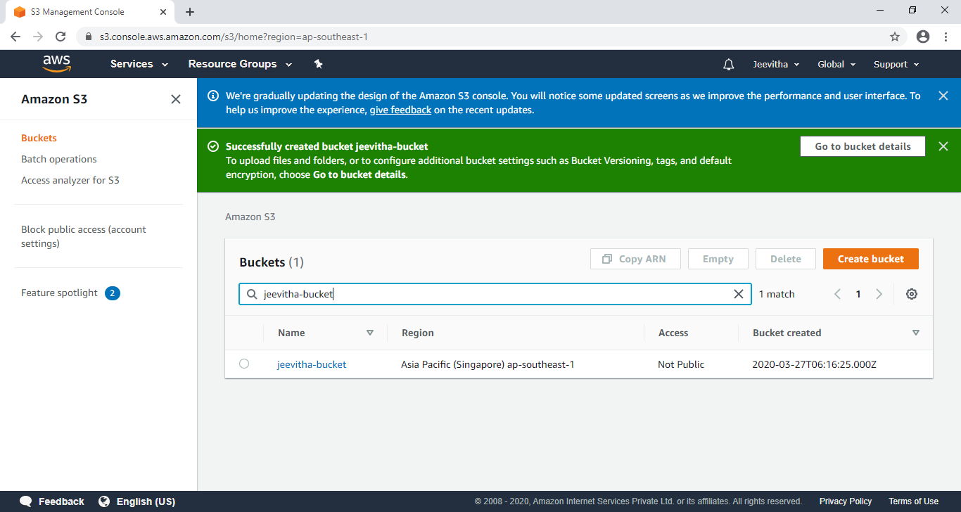

4.REKOGNINTION DASHBOARD

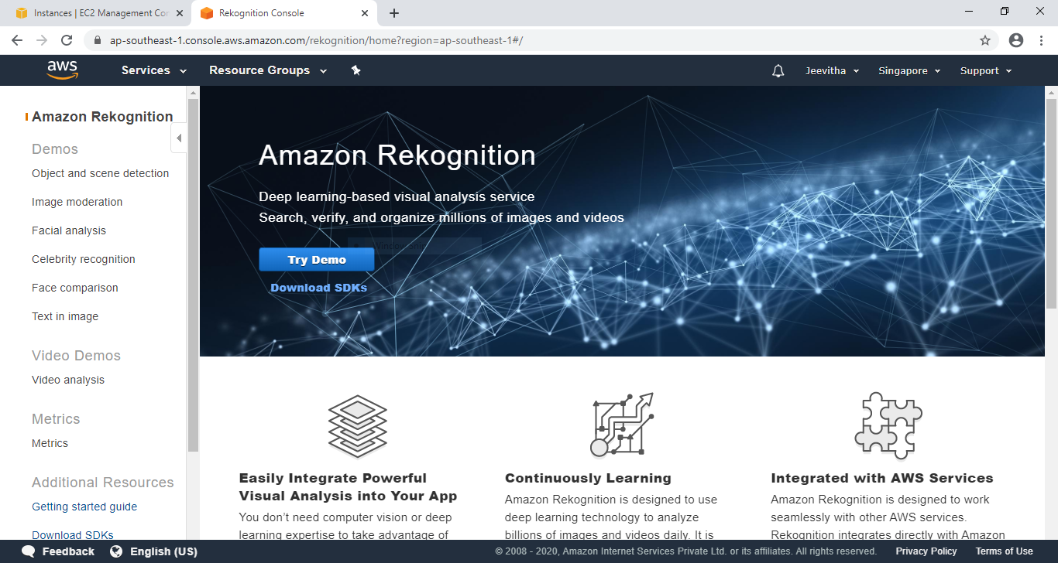

EC2 SCREENSHOTS(7)

5.CHOOSE AMI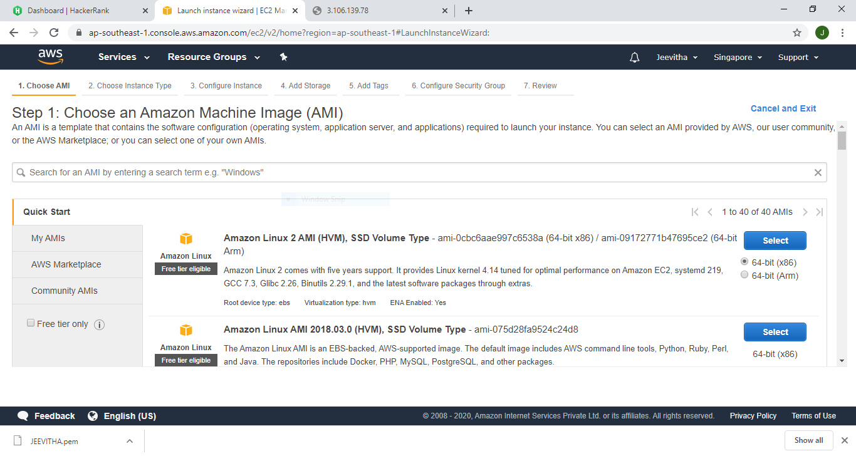

6.CHOOSE INSTANCE TYPE

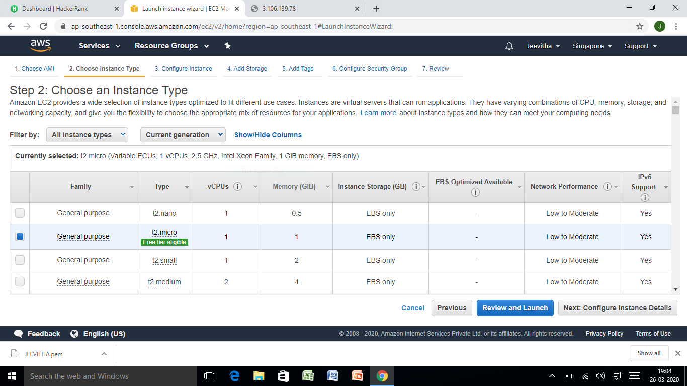

7.ADD STORAGE

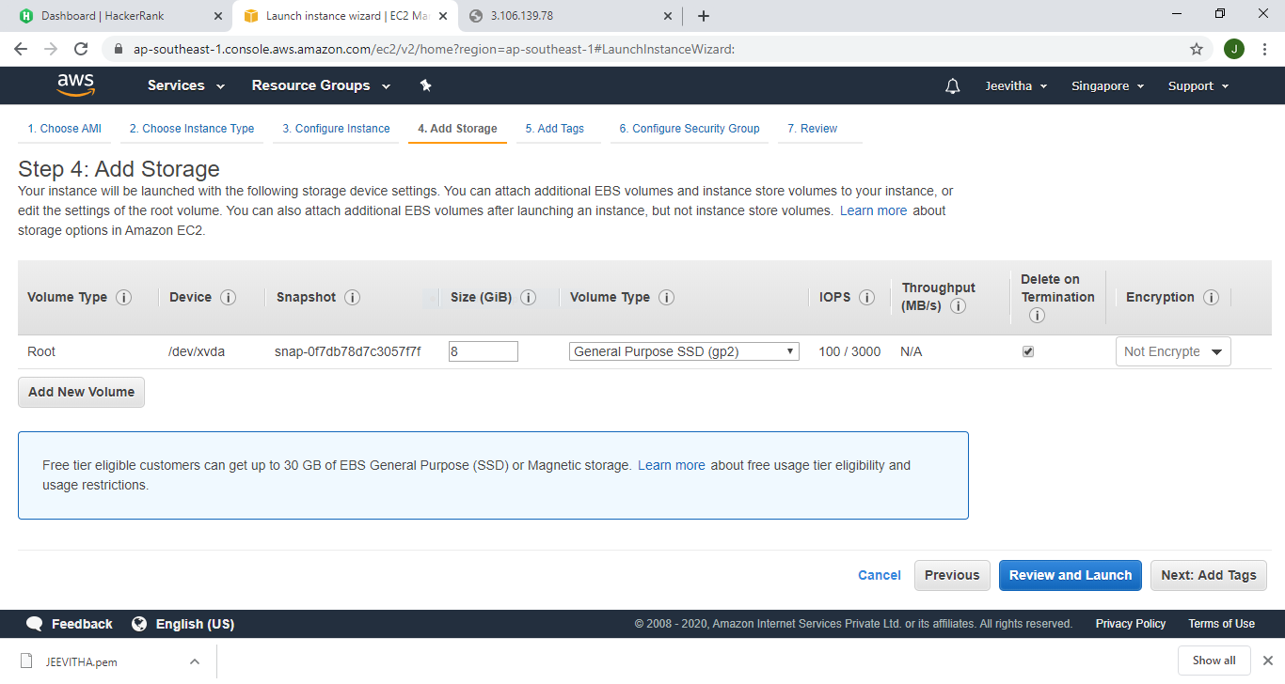

8.CONFIGURE SECURITY GROUP

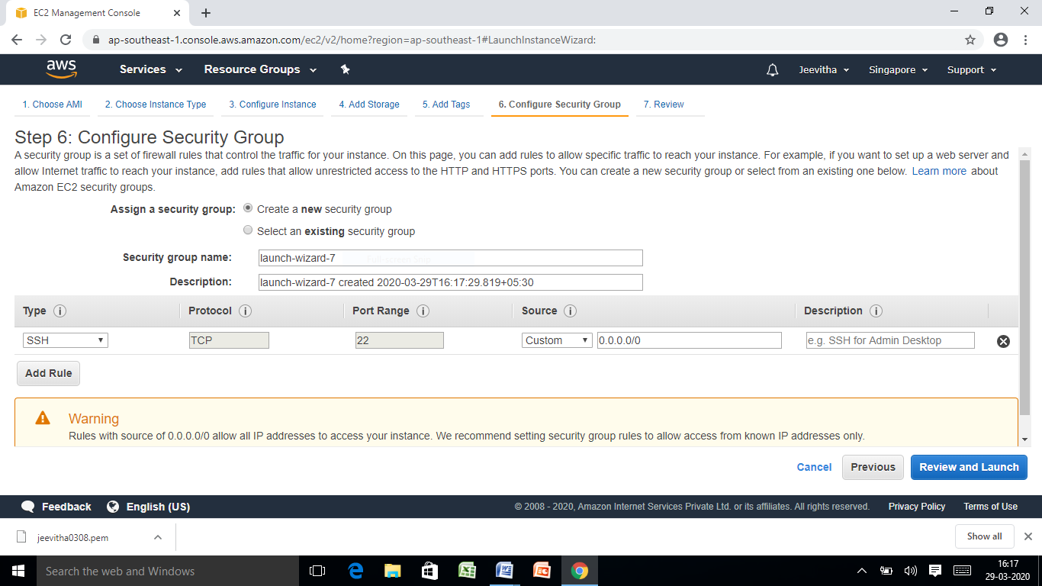

9.KEY PAIR NAME

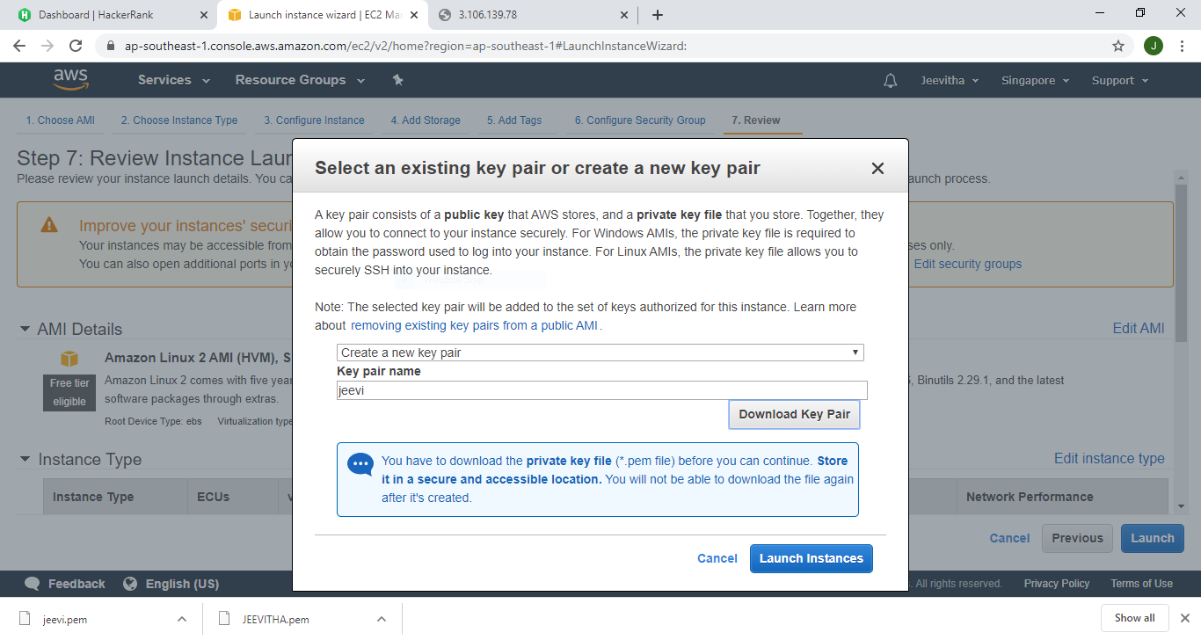

10.PUTTYGEN

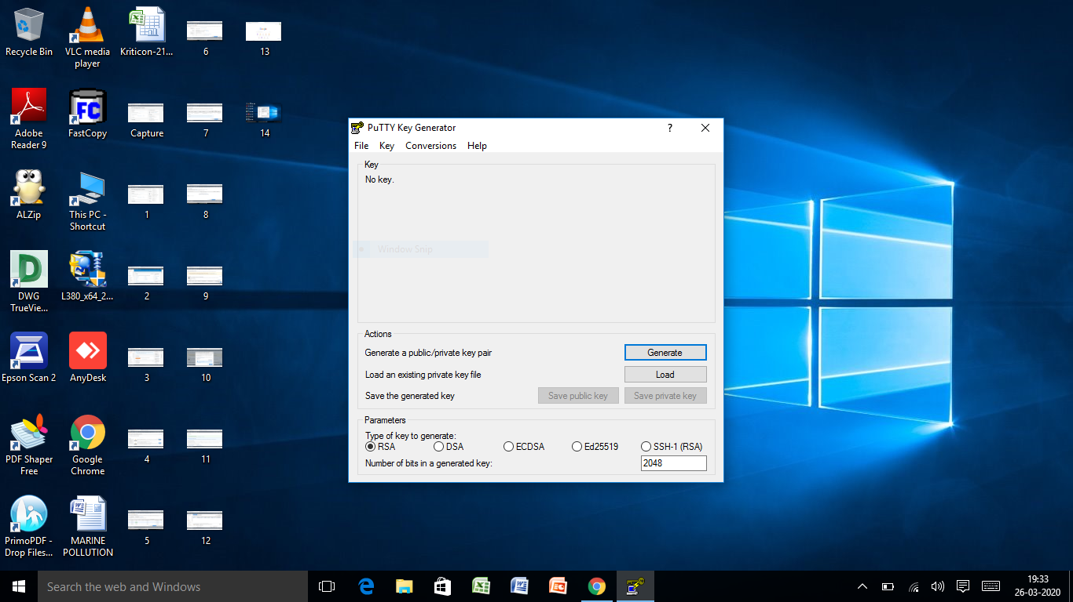

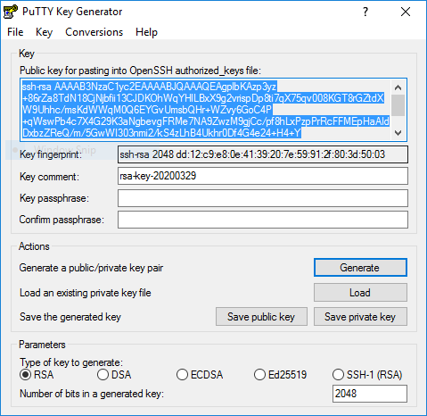

11.EC2 BLACKSCREEN -PUTTY

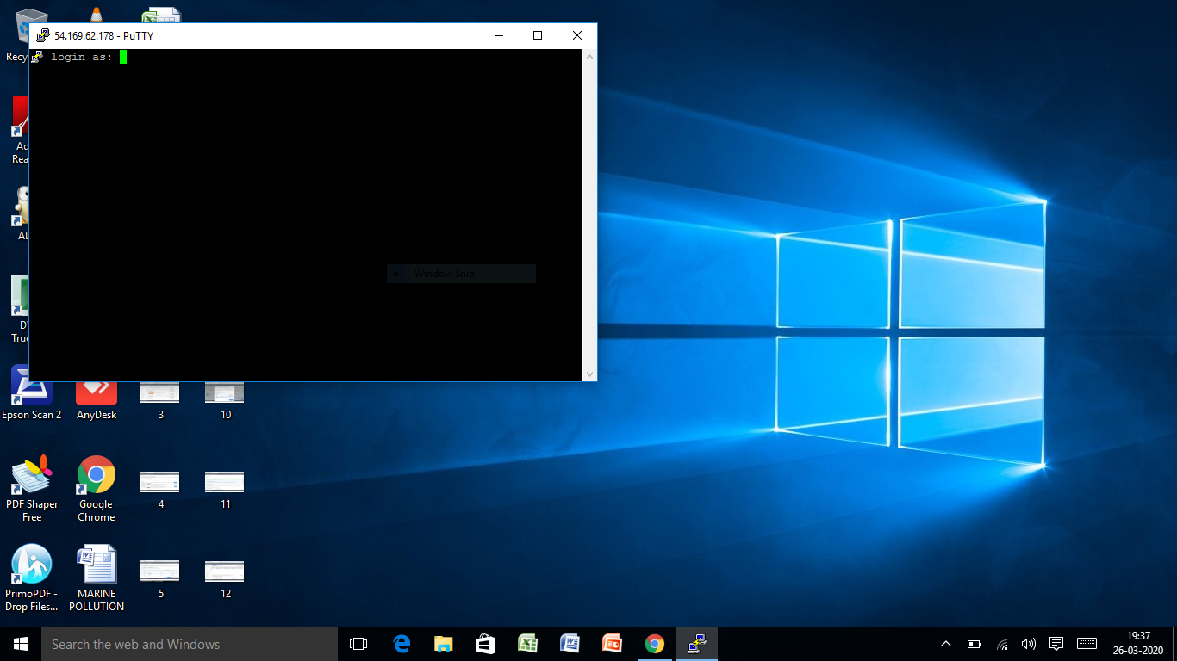

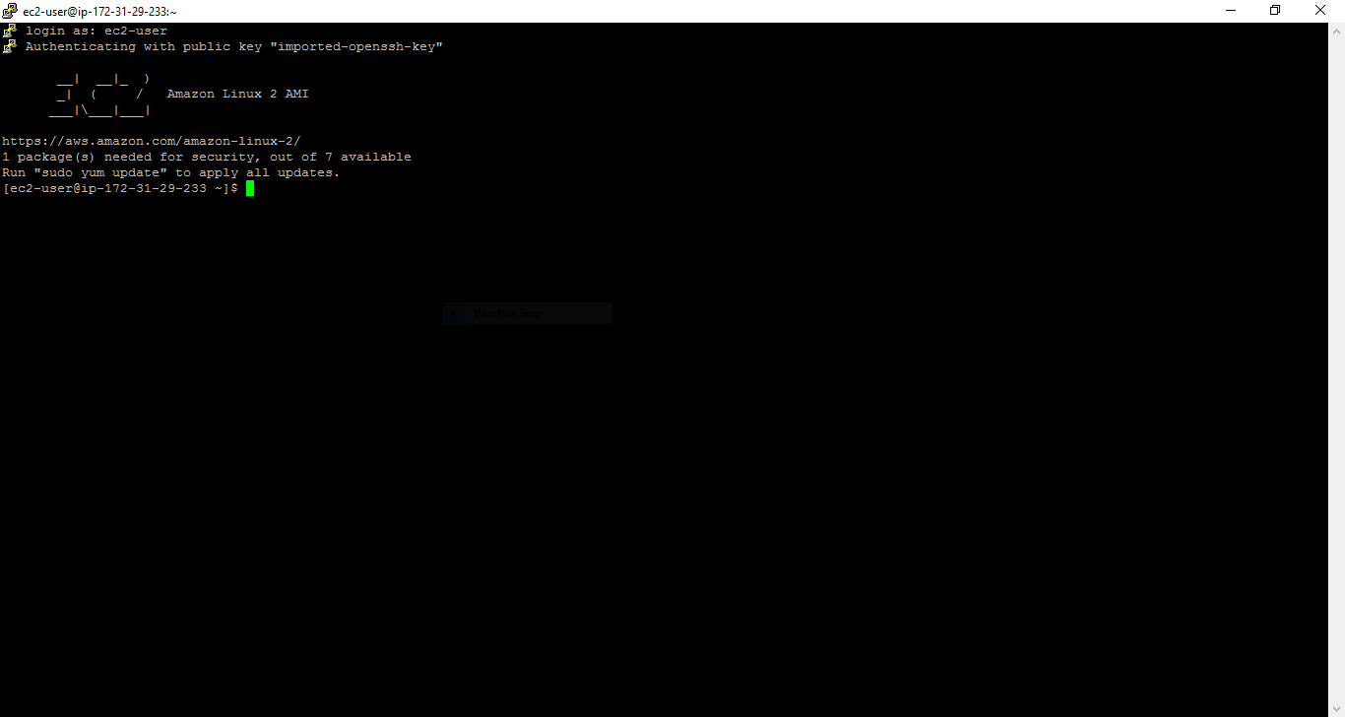

S3 SCREENSHOTS(5)

12.CREATE S3 BUCKET

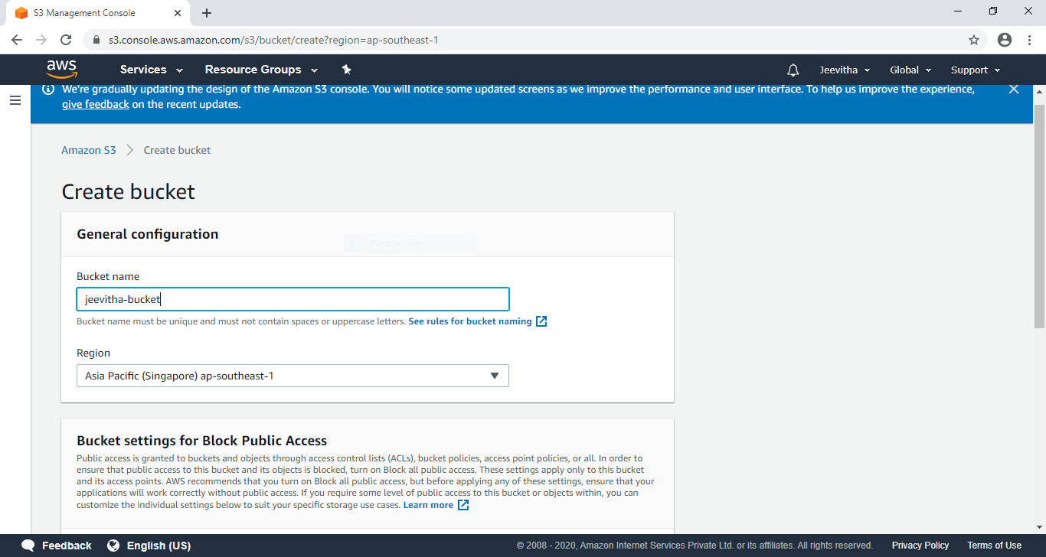

13.UPLOAD S3 BUCKET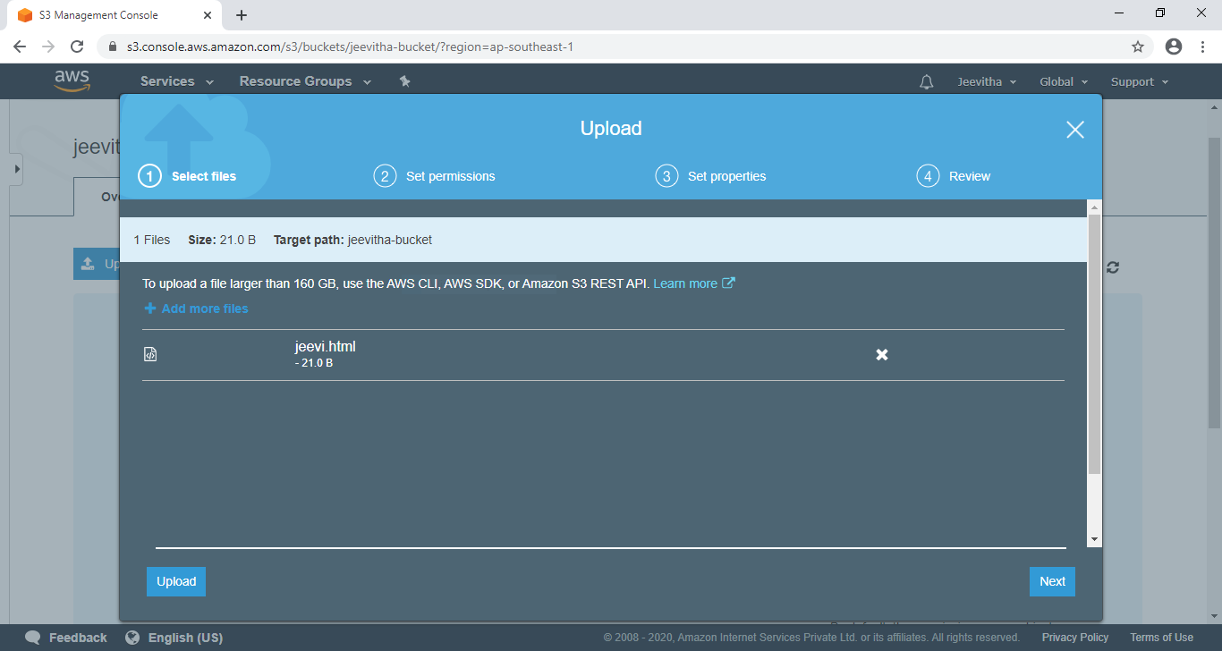

14.STATIC WEBSITE HOST

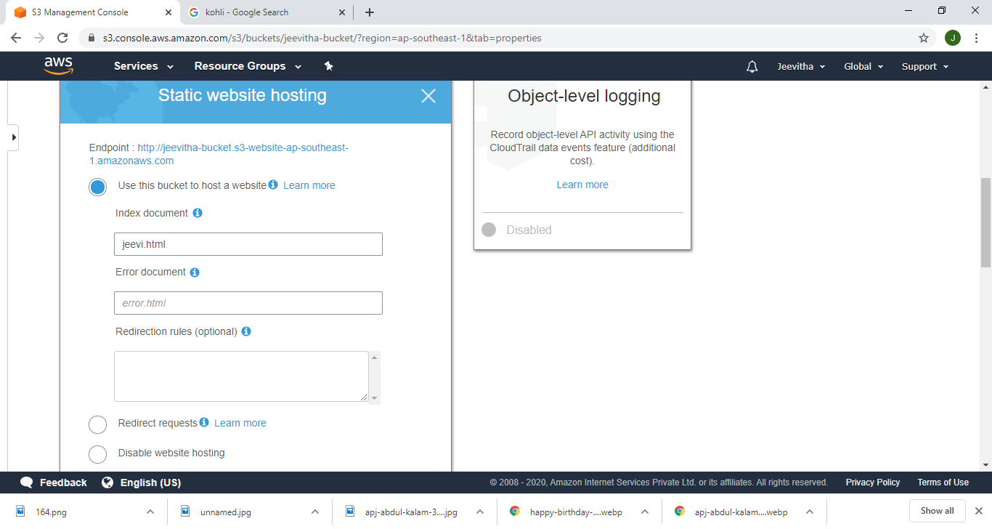

15.MAKE PUBLIC ACCESS

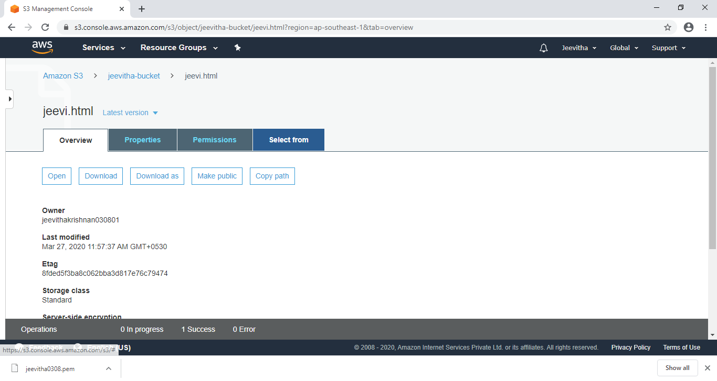

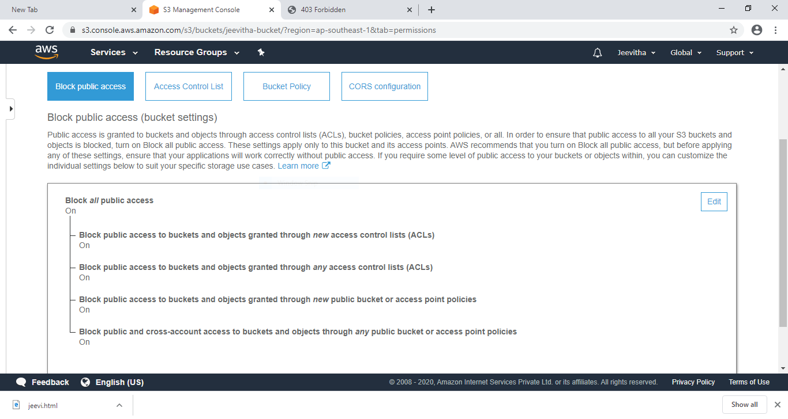

16.CHECKING S3 LINK ON WEBSITE

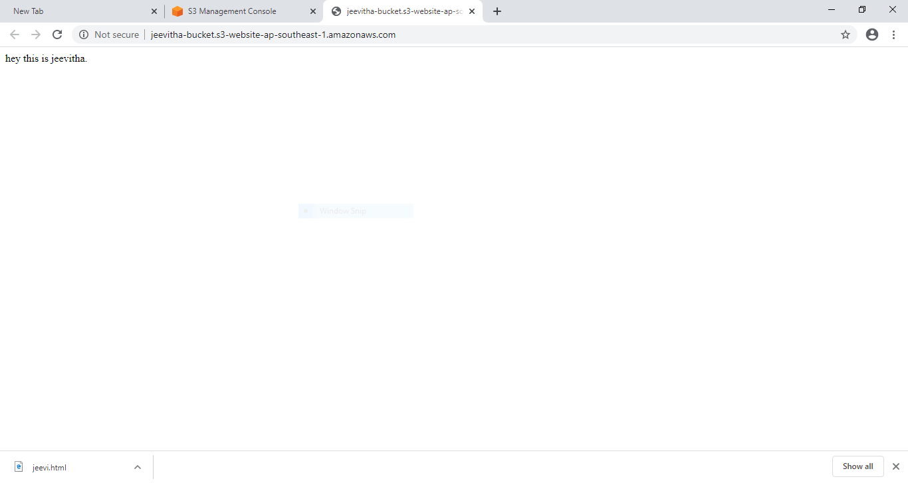

REKOGNITION SCREENSHOTS(4)

17.FACE DETECTION

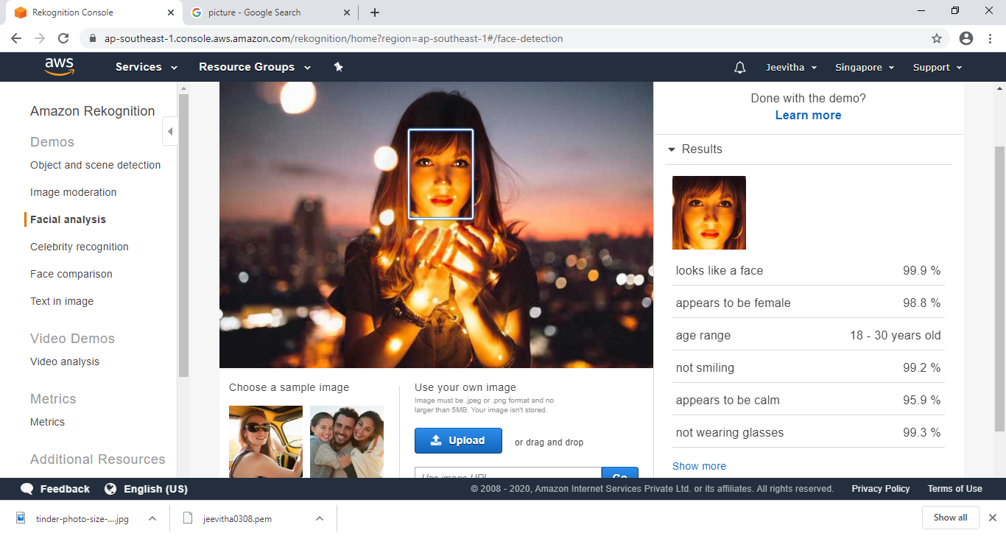

18.CELEBRITY RECOGNITION

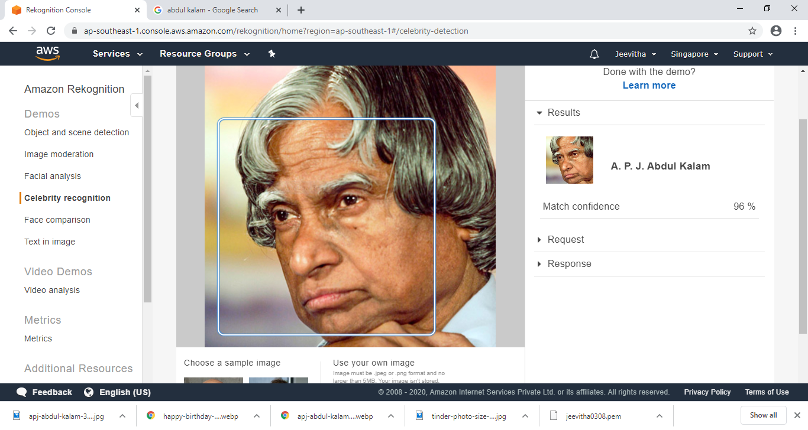

19.FACE COMPARISON

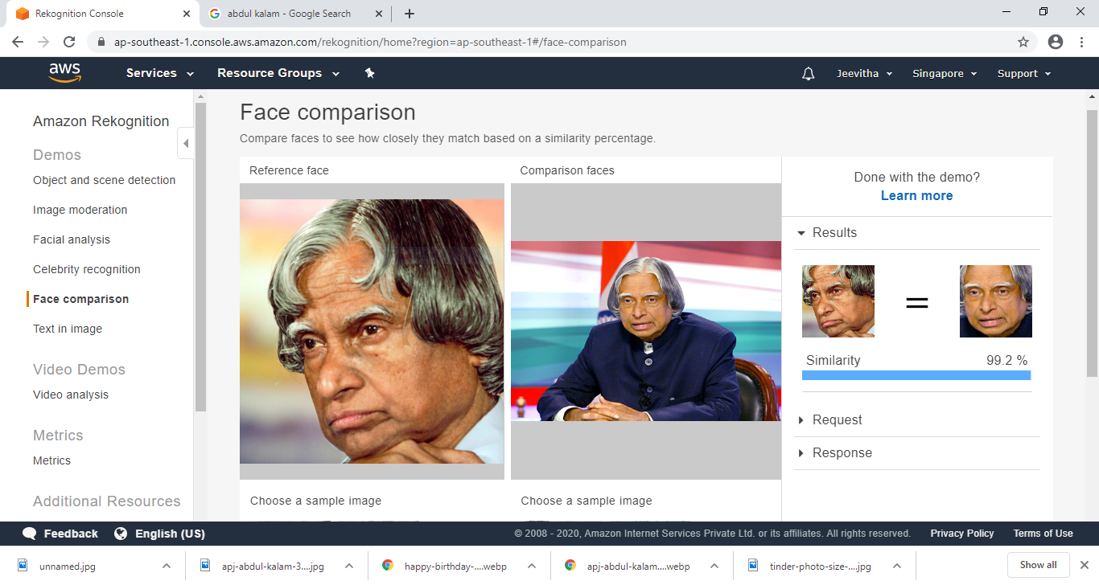

20.TEXT IN IMAGE

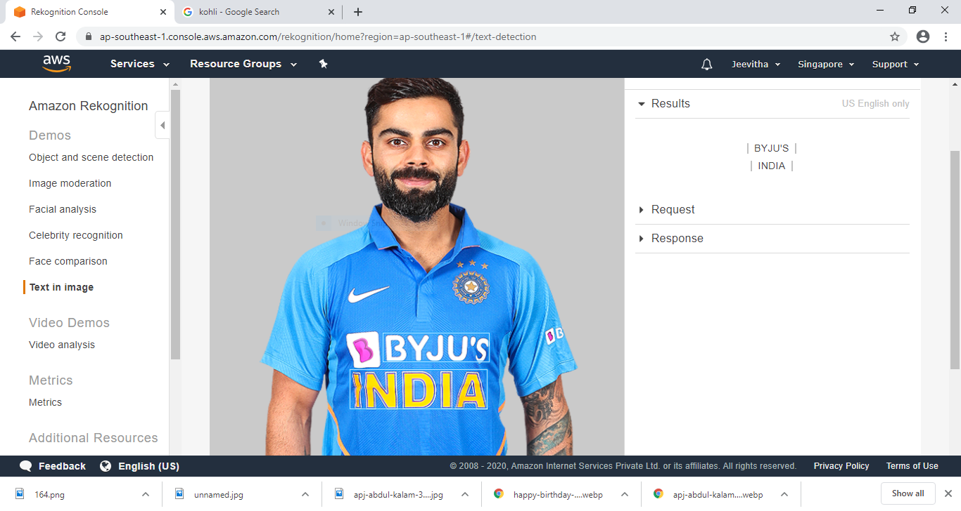

EC2 & S3 SCREENSHOTS(4)

21.INSTALL PHP

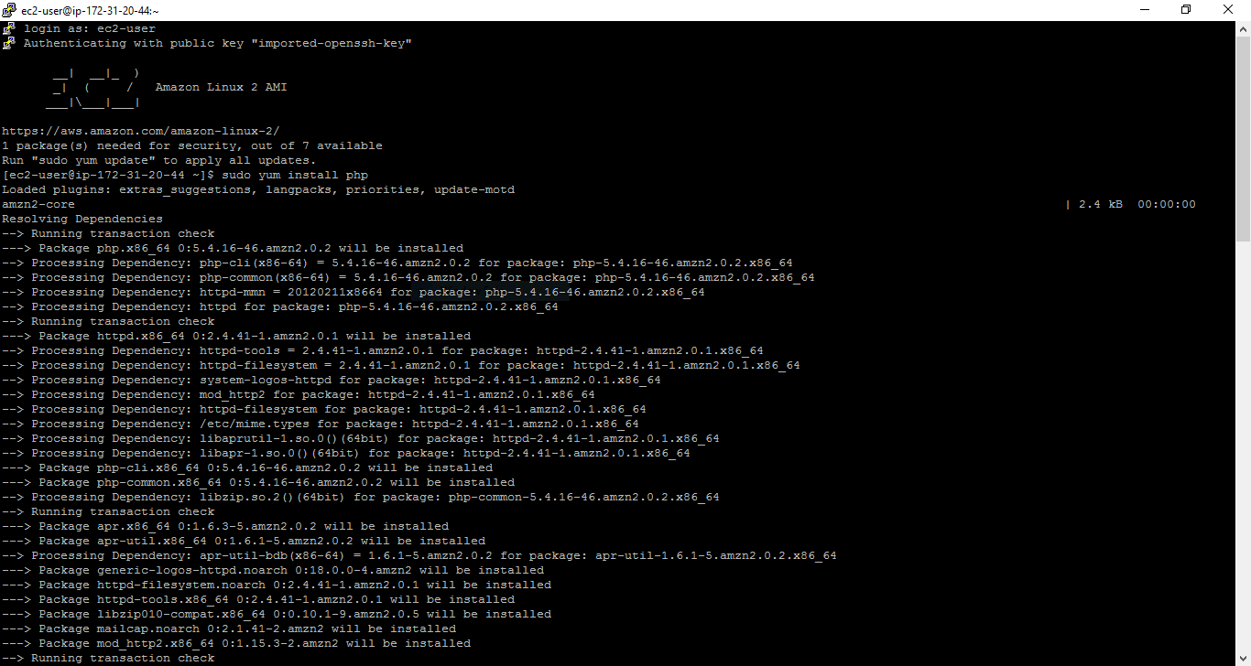

22.INSTALL SDK

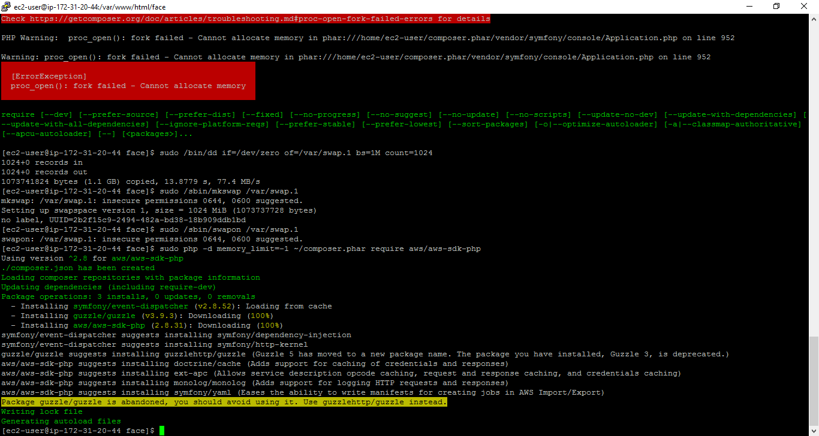

23.PHP FILE INTO CODE

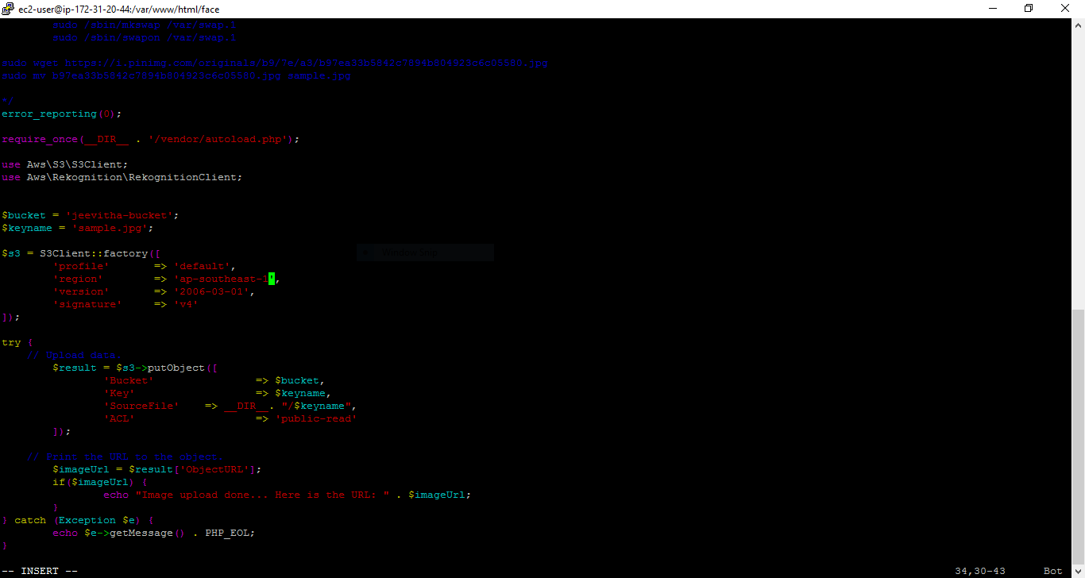

24.IMAGE UPLOAD DONE

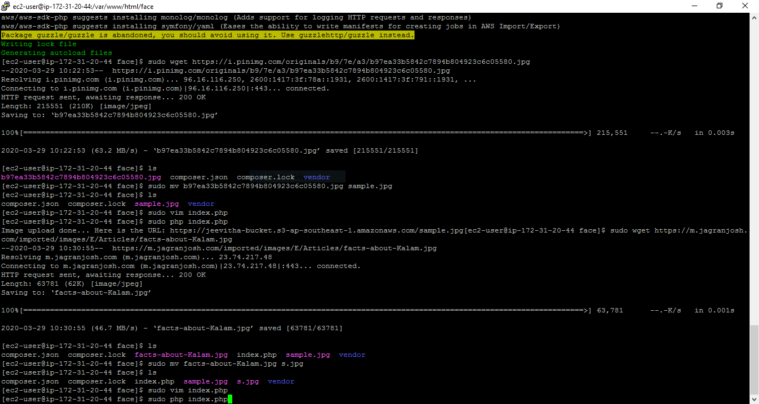

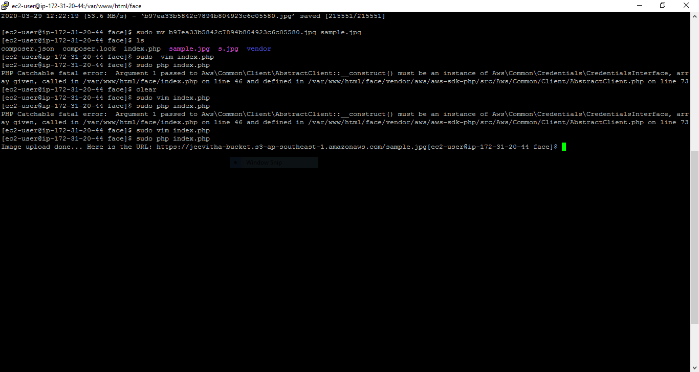

25. FACE RECOGNITION SCREENSHOT

